

DEVELOPMENT OF A HYBRID HUMAN RESOURCES MONITORING SYSTEM

BY

ADEKUNLE, UGWU HASSAN
(SEN/19/0123)

A FINAL YEAR PROJECT IN THE DEPARTMENT OF SOFTWARE ENGINEERING, SCHOOL OF COMPUTING SUBMITTED IN PARTIAL FULFILMENT OF THE REQUIREMENTS FOR THE AWARD OF THE DEGREE OF BACHELOR OF TECHNOLOGY (B.TECH) IN SOFTWARE ENGINEERING OF THE FEDERAL UNIVERSITY OF TECHNOLOGY, AKURE, NIGERIA

SEPTEMBER, 2025

DECLARATION
I hereby declare that this project was written by me and is a correct record of my own research work. It has not been presented in any previous application for any degree of this or any other University. All citations and sources of information are clearly acknowledged by means of references.

Candidate’s Name: ADEKUNLE, UGWU HASSAN
Signature: …………………………………………………… Date: ………………………

CERTIFICATION
I certify that this project titled “Development of a Hybrid Human Resources Monitoring System” is the outcome of the research carried out by Adekunle, Ugwu Hassan in the Department of Software Engineering, The Federal University of Technology, Akure.

Supervisor’s Name: Prof. A. B. Software
Signature:____________________ Date:________________________

ACKNOWLEDGEMENTS
(Ensure you acknowledge your supervisor by stating his/her name correctly with initials and title. Acknowledge all the lecturers in the department and non-teaching staff who contributed to the success of your academic career in FUTA. Also, acknowledge the Dean of SOC and other lecturers in the School who contributed to your academic success by stating their names.)
Your can acknowledge other people you wish.

DEDICATION
This project work is dedicated to

ABSTRACT
Globalization, evolution of computer technology and the fast pace of technological advancements have affected every facet of human lives and endeavours. The effects are becoming noticeable in the field of Human Resources Management (HRM). (The abstract should be one paragraph – there should be no breaking into sections or paragraphs)
TABLE OF CONTENTS
CONTENTS PAGE
Title Page i
Declaration ii
Certification iii
Acknowledgements iv
Dedication v
Abstract vi
Table of Contents vii
List of Tables x
List of Figures xi
CHAPTER ONE 1
1. INTRODUCTION 1
1.1 Background to Study 1
1.2 Research Motivation 4
1.3 Research Aim and Objectives 6
1.4 Methodology 6
1.5 Organization of the Project 8
CHAPTER TWO 10
2.0 LITERATURE REVIEW 10
2.1 The Concept of Human Resource Management 10
2.2 Review of Human Resource Management 10
2.2.1 HRM practices in the pre-technological era 14
2.2.2 Transition of HRM to Electronic HRM (E-HRM) 25
2.2.3 E-HRM Activities 30
2.3 Location Based Services and Evolution of Electronic Monitoring 34
2.4 Positioning Techniques and Systems 48
2.5 Review of Radio Frequency Identification (RFID) Technology 64
2.5.1 RFID Components 66
2.5.2 RFID Standards 70
2.6 Global Positioning System (GPS) 76
2.7 Smart Workplace Technologies and Internet of Things 85
2.8 Review of existing tracking systems 86
CHAPTER THREE 117
3.0 METHODOLOGY
3.1 Overview of the Model/Method/Algorithm 117
3.2 Mathematical Representation 117
3.3 System Architecture 117
3.4 HR and Organization Database 119
3.4.1 HR Personnel Biodata 119
3.4.2 Organization Buildings and Fixed Locations 119
3.4.3 Electronic devices 120
3.5 Localization and Positioning Data Generation 120
3.5.1 Indoor positioning estimation 121
3.5.2 Outdoor Positioning Estimation 127
3.5.3 Multi Camera Surveillance System 134
3.5.4 Signals-denied areas 137
3.5.5 Microcontroller 137
3.5.6 GPRS, UMTS and LTE 138
3.5 Hybrid Location Engine 139
3.5.1 Kalman filtering of hybridized system 145
3.5.2 Error filtering and correction 147
CHAPTER FOUR 149
4.0 IMPLEMENTATION, RESULTS AND DISCUSSIONS 149
4.1 Overview of the Chapter 149
4.2 System Requirements 149
4.3 Experimental setup 53
4.4 System Implementation 55
4.4.1 Enrolment of Personnel 56
4.5 Case study of selected personnel 60

CHAPTER FIVE CONCLUSION AND RECOMMENDATIONS
5.1 Conclusion 67
5.2 Contribution to knowledge 67
5.3 Suggestions for further research 67
5.4 Recommendations 68
REFERENCES 69
APPENDIX A 74
APPENDIX B 75

LIST OF FIGURES
Figures Page
2.1 Nigeria as at 1960 32

LIST OF TABLES
Table Page
2.1 Comparison of RFID Tags 32
2.2 Advantages and Disadvantages of RFID Frequencies 34
2.3 RFID Tag Applications with Corresponding bands 35
4.1 Specifications for Alien ALR 8800 RFID Reader 54
4.2 Specifications for Alien Squiggle Passive Tag 54

CHAPTER ONE

INTRODUCTION
1.1 Background to Study
1.2 Research Motivation
1.3 Research Aim and Objectives
1.4 Methodology
1.5 Organization of the Project

CHAPTER TWO
LITERATURE REVIEW
2.1 The Concept of Human Resource Management
2.2 Review of Human Resource Management
2.2.1 HRM practices in the pre-technological era
2.3 Location Based Services and Evolution of Electronic Monitoring
2.4 Positioning Techniques and Systems
2.5 Review of Radio Frequency Identification (RFID) Technology
2.5.1 RFID Components
2.6 Related Works

CHAPTER THREE
METHODOLOGY

3.1 Overview of the Model/Method/Algorithm
The proposed study utilizes [Name of Model/Algorithm, e.g., Deep Learning, Machine Learning, AI, Statistical Model] to solve [mention the research problem]. The choice of this model is due to its [mention advantages, e.g., high accuracy, scalability, ability to learn from data].

3.2 Mathematical Representation
The mathematical formulation of the [chosen model/algorithm] is presented below.

3.2.1 Model Formulation
3.2.2 Algorithm Pseudocode
Algorithm: Model Training and Prediction
1. Initialize model parameters θ
2. Load dataset (X, Y)
3. Split dataset into training and testing sets
4. Train model using backpropagation and gradient descent:
a. Compute loss function L(y, ŷ)
b. Update model parameters θ using:
θ = θ - α * ∇J(θ)
5. Validate model on test set
6. Evaluate performance using accuracy, precision, recall, and F1-score
7. Return trained model

3.3. System Architecture
The system architecture defines the overall structure of the proposed solution. It includes various components such as data preprocessing, model training, prediction module, and evaluation module.

3.3.1 System Components
- Data Collection Module – Collects data from [mention sources, e.g., social media, databases, APIs].
- Preprocessing Module – Cleans and transforms data for model training.
- Model Training Module – Trains the [model name] using labeled data.
- Prediction Module – Uses trained model to classify and predict outcomes.
- Evaluation Module – Assesses model performance using [evaluation metrics].

3.3.2 System Architecture Diagram
(Insert a diagram illustrating the system architecture)

3.4. UML Diagram & Flowchart

3.4.1 UML Diagram
Unified Modeling Language (UML) diagrams illustrate the system's components and their interactions.
(Insert UML diagrams such as Use Case Diagram, Class Diagram, or Sequence Diagram as applicable)

3.4. UML Diagram & Flowchart

3.4.1 UML Diagram
Unified Modeling Language (UML) diagrams illustrate the system's components and their interactions.
(Insert UML diagrams such as Use Case Diagram, Class Diagram, or Sequence Diagram as applicable)

3.4.2 Flowchart of the Proposed Model
A flowchart represents the step-by-step flow of the research process.
(Insert a flowchart detailing the workflow of the system)

3.5 Evaluation Methods

3.5.1 Model Performance Metrics
The proposed model is evaluated using the following metrics:

EXAMPLE OF CHAPTER THREE TO FIVE IS SHOWN BELOW

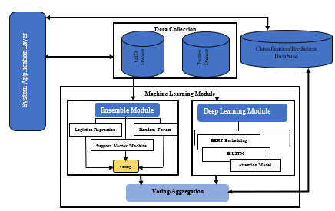
Figure 3.1: Architecture of the Recommender System

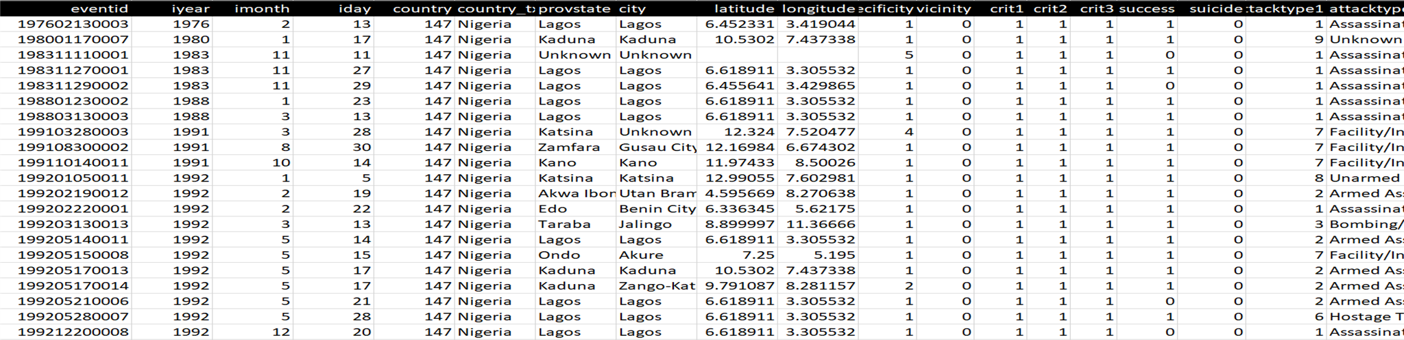
Table 3.1: GTD Data Schema

3.3 Data Handling
The ensemble module was used for structured data and deep learning module was used for unstructured data.

3.3.1 Structured Data
The work used ensemble machine learning model for the structured dataset which is made up of Logistic regression, Support Vector Machine, and Random Forest as shown in Figure 3.2.

Position Embeddings
In addition to Token embeddings, which are used to represent every word or subword that the model can comprehend, BERT also uses Position Embeddings, which show where each token is in the input tweets as shown in Figure 3.6. BERT has 30,522 different token embeddings and only 512 different position embeddings. This is due to the fact that the largest input sequence accepted by the BERT model is 512 tokens long.

Segment Embeddings
Segment embedding is also referred to as sentence embedding and use to determines whether two given sentences A and B, logically follows each other which is illustrated by Figure 3.7. That is, given two sentences A and B, BERT was trained to determine whether B logically follows A.

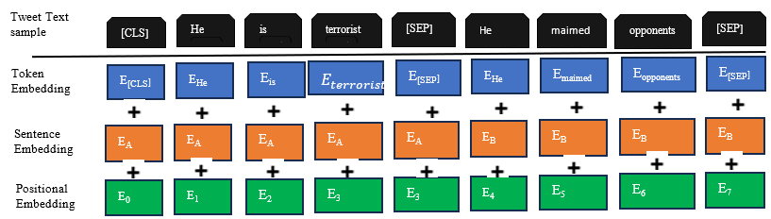
Figure 3.4: BERT Embedding Layer

Figure 3.5: Token Embeddings

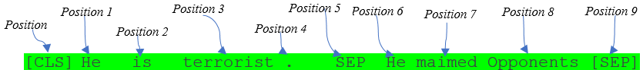
Figure 3.6: Positional Embeddings

Figure 3.7: Segment Embeddings

3.3.2.3 Long Short Term Memory (LSTM) and Bidirectional Long Short Term Memory (BiLSTM)

Long Short Term Memory (LSTM) provide long-term dependency by remember long term information. LSTM layer consists of a memory cell, which remembers values over arbitrary time intervals and each cell housed four components called gates, namely; input gate ($i_{t}$), output gate ($o_{t}$), forget gate ($f_{t}$) and C_{t} gates that regulate the flow of information in and out of the cell which are shown Figure 3.8 – 3.11.
Apart from the listed gates, LSTM has some notations which is shown in Table 3.3.
The f_{t} decides what should be forgotten from the cell state with the help of the sigmoid function (σ) by squash the output values in closed range [0,1], where 0 means the text is irrelevant to the context and should be remove completely while 1 means the text is relevant and should be keep as it is. The f_{t} concatenates at hₜ₋₁ and xₜ, and outputs a value between 0 and 1 for each vector in the cell state Cₜ₋₁.
Forget gate f_{t} is obtained using Equation 3.15;
ft=σWf.ht-1,xt+bf (3.15)
where σ denote element-wise SoftMax function, Wf denotes weight of the encoded vector, ht-1 denotes value of the previous hidden layer. where 𝑥_{𝑡} is word embedding of the tweet input at time-step 𝑡, bf is the offset vector and ⊙ is the element-wise product
σxt=SoftMaxxt= extt=1Text (3.16)

3.6 Experimental Tool Requirements
The system will be implemented with Python programming language in Jupyter Notebook using NLP and Deep learning packages such as Keras, TensorFlow, sklearn, NumPy, Panda, NLTK while the web app will be implemented using Laravel framework.
Keras and TensorFlow: Both Keras and TensorFlow are widely-used deep learning frameworks known for their ease of use, flexibility, and extensive community support.
Scikit-learn (sklearn): Sklearn is a robust Python machine learning toolkit that offers easy-to-use and effective tools for selecting, preparing, and evaluating models. It works nicely with a wide range of other Python libraries, including Pandas dataframe, NumPy for array vectorization, and matplotlib for graphing, among many others.
Pandas: Python package that is used to work with data collections. It has tools for exploring, cleaning, analyzing, and modifying data.
NumPy: It is an open-source numerical Python library; it provides an array object that is up to 50x faster than traditional Python lists. A single dimensional array is referring to as vector.
NLTK (Natural Language Toolkit): NLTK is a popular Python library for natural language processing. It provides easy-to-use interfaces for tasks like tokenization, stemming, tagging, parsing, and more.
WAMP: This is a software package that house Apache, MySQL and PHP.
Composer: It is a tool for managing PHP dependencies and also utilize the third part library without embedding it with source code.
Laravel Framework: It is a PHP cross-platform framework for building web application loaded with pre-programmed functionality.
Google API: Google Application Programming Interface can be used by the developers to access Google Maps functionality and data for their own projects.

3.7 Evaluation Metrics for the Proposed Model
The accuracy, precision, recall, specificity, and F1 score will be use as evaluation metrics.
Accuracy
Accuracy is the number of correct predictions divided by the number of total predictions.
$$Accuracy = \frac{TP+TN}{TP+TN + FP + FN} (3.36)$$
Precision
The presence of predicted positive that is actually positive. It is also called the Positive Predicted Value (PPV).
$Precision = \frac{TP}{TP + FP} (3.37)$
Recall
The percentage of samples that yielded positive results relative to the total number of samples that were positive. Another name for it is Sensitivity.
$Recall = \frac{TP}{TP + FN} (3.38)$
Specificity
The percentage of negative outcomes relative to the total number of samples that were truly
negative.
$Specificity = \frac{TN}{TN+ FP} (3.39)$
F1-Score
F1 Score is the harmonic mean of Precision and Recall.
$F1 score =2*\frac{Precision * Recall}{Precision+ Recall} (3.40)$

CHAPTER FOUR

IMPLEMENTATION

4.1 Overview of the System Implementation
This chapter presents the experimental setup, the implementation and validation of the proposed system and the results obtained. The proposed system was implemented using python programming language. Python was chosen for the task because it is an open source language with great support for machine learning tasks. It is also having interactive shell which allows for viewing and inspection of element during implementation.

4.2 Experimental Set Up
The implementation of the proposed machine learning model for terrorism prediction in Nigeria was carried-out in a computing environment characterized by the following requirements.

4.2.1 Hardware Requirements
The proposed system was implemented using Dell Inspiron 7076 with the following configuration; Intel Core i7, 12th Gen, 32GB RAM with 8 cores, 1TB SSD, 8GB NVIDIA RTX A2000.

4.2.2 Software Requirements
The system was implemented with Python 3.11 programming language, Jupiter Notebook using NLP and Deep learning frameworks and packages such as Keras, TensorFlow, sklearn, NumPy, panda, NLTK while the web app will be implemented using Laravel framework.
Keras and TensorFlow: Both Keras and TensorFlow are widely-used deep learning frameworks known for their ease of use, flexibility, and extensive community support.
Scikit-learn (sklearn): Scikit-learn is a powerful library for machine learning in Python, providing simple and efficient tools for data preprocessing, model selection, and evaluation. It integrates well with many other Python libraries, such as matplotlib for plotting, NumPy for array vectorization, Pandas DataFrames and the like.
Pandas: Pandas is a Python library used for working with data sets. It has functions for analyzing, cleaning, exploring and manipulating data.
NumPy: It is an open-source numerical Python library; it provides an array object that is up to 50x faster than traditional Python lists. A single dimensional array is referring to as vector.
NLTK (Natural Language Toolkit): NLTK is a popular Python library for natural language processing. It provides easy-to-use interfaces for tasks like tokenization, stemming, tagging, parsing, and more.
WAMP: This is a software package that house Apache, MySQL and PHP.
Composer: It is a tool for managing PHP dependencies and also utilize the third part library without embedding it with source code.
Laravel Framework: It is a PHP cross-platform framework for building web application loaded with pre-programmed functionality.
Google API: Developers use the Google Application Programming Interface to access Google Maps functionality and data for their own projects.
Importing the Required Libraries
The code writing in Python starts by importing the various libraries, including:
- pandas for data manipulation
- torch for building the neural network
- sklearn for data preprocessing and model evaluation
- transformers for pre-trained BERT models
- sqlalchemy for interacting with databases
- matplotlib for plotting
The necessary libraries are imported Python code (See APPENDIX C for libraries import code snippets)

4.3 Data Pre-processing Stage
The model loads the GTD and scraped dataset from the CSV files using pd.read_csv for subsequent processing by both ensemble module and deep learning respectively. Empty columns were removed to optimized the model by using dropna(axis=_) function. In order to reduce the bias of the model, missing data were handled with Multiple Imputation Techniques because the data is both numerical and categorical. .isna() function was used to display a dataframe with True value for missing value with NaN type(See APPENDIX C for code to drop column with missing values). The text is then pre-processed using a custom function preprocess_text and sklearn.preprocessing.LabelEncoder to convert the categorical target column to numerical one (See APPENDIX C for LabelEncoder code).

4.4 Model Training and Testing
The pre-processed data is splits into train and test sets using sklearn.model_selection.train_test_split. The input features (text data) were tokenized using the BertTokenizer from the transformer’s library and the TensorDataset and DataLoader were also created from PyTorch for the BiLSTM model using the embedding tokenized input features and label-encoded target values from the BERT model.
The BERT architecture consists of training parameters such as input/output shape where batch size is said to be 16, input features which consist of the tokenizes text data, number of epochs, which is 7 and 3. The AdamW was used as the optimizer for the model.

4.5 Results and Discussions
Implementation of the proposed model for the terrorism prediction was achieved using Jupyter notebook, python programming language, WAMP server. The datasets from both GTD and social media which consist of 5,550 records in total was divided into two parts:
Training (80%) equal to 4,440 instances
Testing (20%) equal to 1,110 instances
An ensemble module (SVM, RF and LR) and deep learning module (BERT, Attention Based-BiLSTM) were applied to both dataset and aggregated using voting ensemble techniques of Bagging model. The resulting accuracy, Precision, Recall, Specificity and F1-Score from the train and test experiment for the ensemble module that is consist of random forest (RF), logistics regression (LR) and support vector machine (SVM) are shown in Table 4.1, Figure 4.1 and Figure 4.2 respectively. In Table 4.1, Random Forest (RF) has the highest value of 98.11%, 97.08%, 98.11%, 99.93% and 97.54% in terms of accuracy, Precision, Recall, Specificity and F1-Score respectively.

Table 4.1: Ensemble Module Comparison
Model | Accuracy | Precision | Recall | Specificity | F1-Score
RF | 98.11% | 97.08% | 98.11% | 99.93% | 97.54%
LR | 97.21% | 94.67% | 97.12% | 99.87% | 95.85%
SVM | 97.84% | 96.49% | 97.84% | 99.90% | 97.10%
Ensemble Model | 97.92% | 96.39% | 97.93% | 99.90% | 97.10%

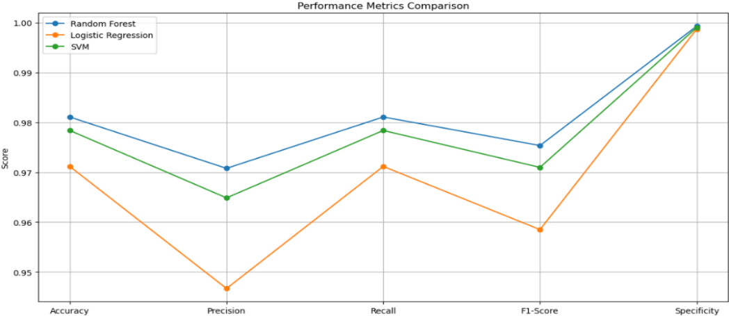
Figure 4.1: Line Graph of Performance Metrics Comparison

Support Vector Machine has the second best result from the ensemble module while the Logistic Regression has the least result but all the three model perform excellently well as shown Table 4.1 and Figure 4.1. Figure 4.2 depicts the bar chart for each of the metrics of the ensemble module that shows the comparison of the models of the of the proposed system.
Table 4.2 contains the training and testing accuracy/loss for seven (7) epochs of BiLSTM. The training loss values ranges from 0.0437 to 0.4495 while the accuracy ranges from 0.9725 to 0.9883. Figure 4.3 shows the training and testing loss of BiLSTM over seven epoch. Figure 4.4 and Figure 4.5 shows the train and test accuracy and confusion matrix of the BiLSTM. The Confusion matrix shows that the model classified the “Fulani extremist” and “boko haram” correctly without making any error.
Figure 4.6 shows the loss of the BERT model which is also ok since it keeps increasing downward to so show that the accuracy keeps improving and Figure 4.7 shows the accuracy of the BERT model. Figure 4.8 and 4.9 shows the performance metrics and their comparison respectively. Table 4.4 and 4.5 consist of the performance metrics of the ensemble and deep learning model and schematic structure of the database that will store the result from the machine learning models from which the Web application will fetch data for the user queries.

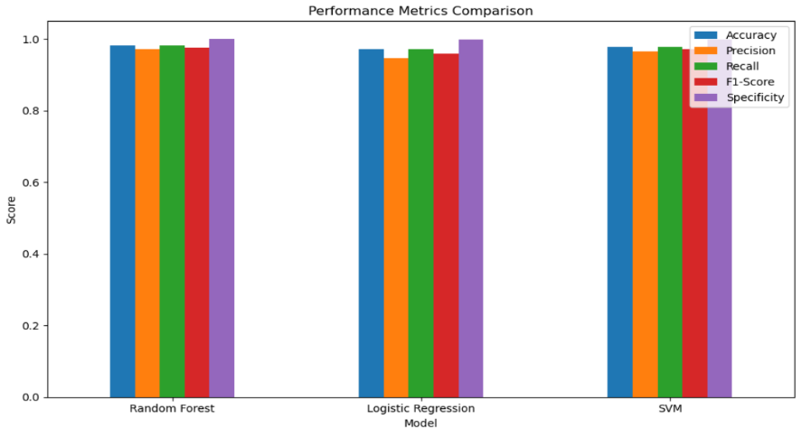
Figure 4.2: Bar Chart of Performance Metrics Comparison

Table 4.4: Performance Metrics of Ensemble and Deep Learning Models
Learning Model | Accuracy | Precision | Recall | Specificity | F1-Score
RF | 98.11% | 97.08% | 98.11% | 99.93% | 97.54%
LR | 97.21% | 94.67% | 97.12% | 99.87% | 95.85%
SVM | 97.84% | 96.49% | 97.84% | 99.90% | 97.10%
Ensemble Module | 97.92% | 96.39% | 97.93% | 99.90% | 97.10%
BERT | 97.43% | 97.08% | 98.11% | 99.93% | 97.54%
BiLSTM | 98.38% | 99.40% | 98.38% | 99.95% | 98.38%

The system application module is a web application, comprises of the front-end and back-end systems. The back-end stores the data resulting from the model’s performance while the front-end allows the user to interact with the system through the user interface of the internet Access enabled devices.
The web application was developed using Laravel framework, Composer, WAMP, Google map API. Figure 4.10 shows the search bar of the web application, from which the user can enter query or keywords such as Boko Haram, Fulani Herdsmen or Hostage Taken. The system, in return display the hits of the search query which consist of the name of the terrorist group that is likely going to responsible for future attack, the likely location of the future attack, the likely attack type that is going to be carry out, the probability which is in percentage (%) that attack is going to happened with the hypothetical date of occurrence as shown in Figure 4.11 and Figure 4.12 respectively.
Figure 4.13 shows the prediction of armed assault with the 59% probability of occurrence. Figure 4.14 and 4.15 also show the prediction of facility attack and hostage taking with the 97% and 54% probabilities of occurrence respectively. Figure 4.16 is the navigational pane of the developed system, which help the user to quickly traverse and play around the hits.
Figure 4.17, 4.18 and 4.19 depicts the prediction of boko haram attack, IPOB attack and Fulani extremist attack will occur with the probabilities of 54%, 43% and 97%, the date of occurrence: 1st of July, 2024, 13th of July 2024 and 13th of July 2024 respectively.

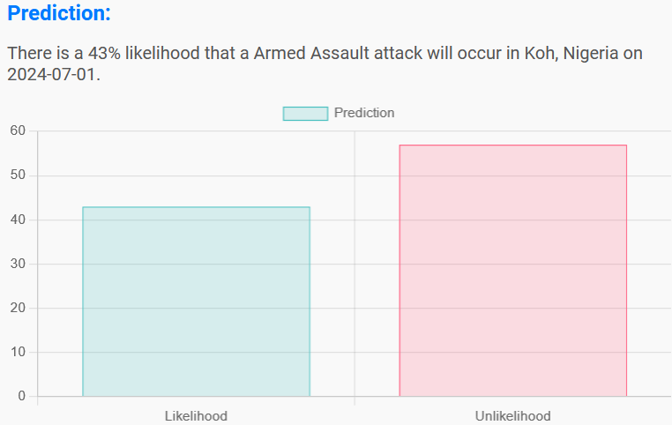
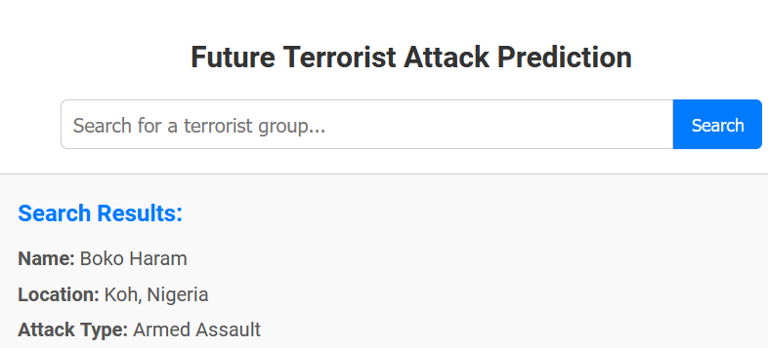
B
A
Figure 4.10: (A) Search Bar/Interface (B) Search Result Figure 4.11: Likelihood of Attack

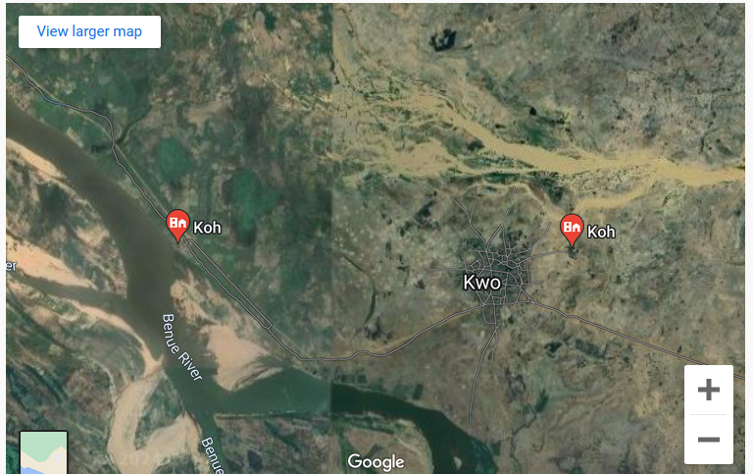
Figure 4.12: The Map Showing the Predicted Location of Attack

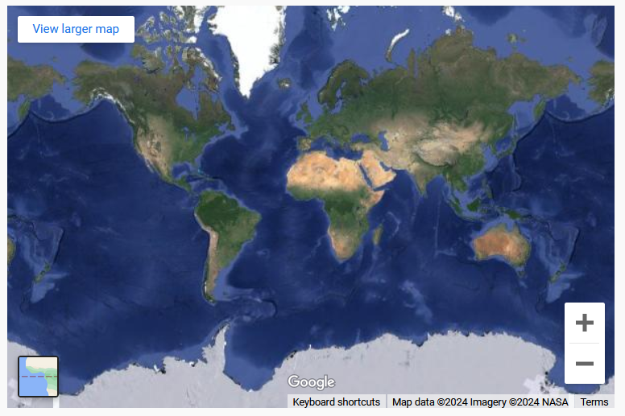
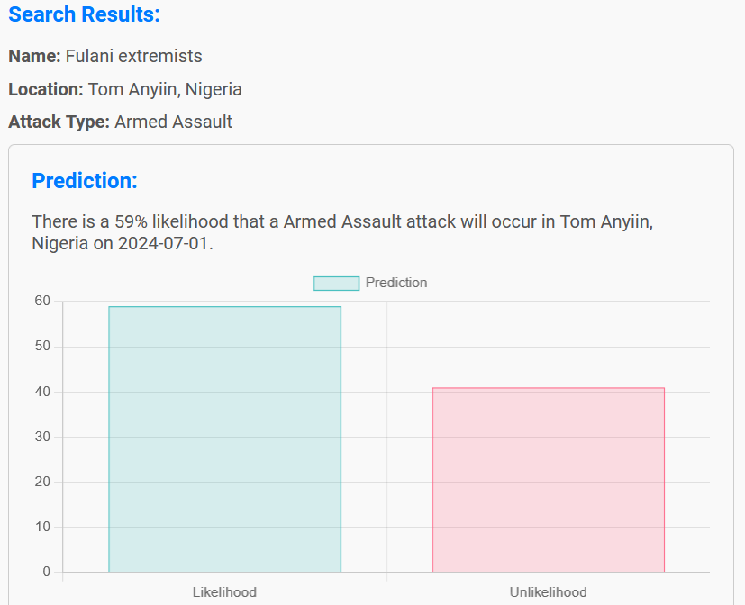
B
B
A

Figure 4.13: (A) Prediction of Armed Assault (B) Map of the Predicted Location

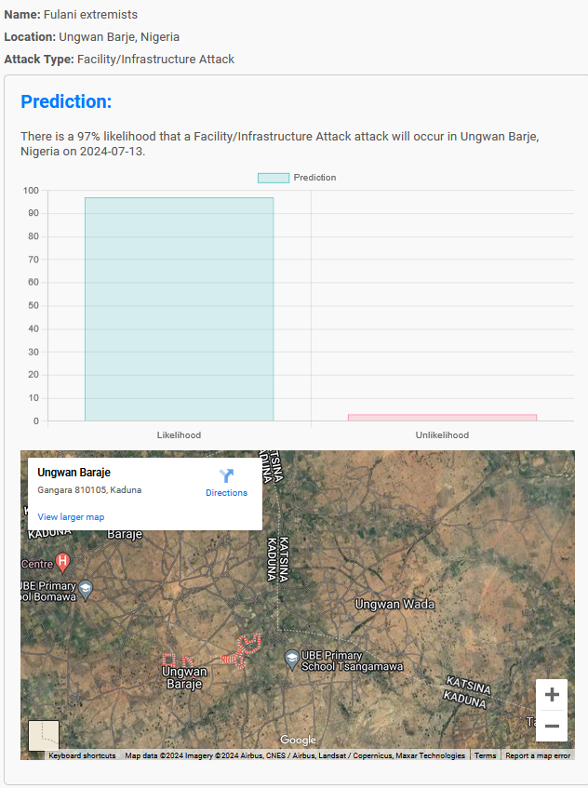
Figure 4.19: Prediction of Fulani Extremist Attack

4.6 System Evaluation
The integrity of a system rest on outcome of its evaluation. As part of the effort to examine the efficiency of the proposed system, standard metrics such as accuracy, precision, recall and F1-Score were used in measuring the models’ performance. Accuracy measures the overall correctness of the model’s predictions, precision measures the accuracy of positive predictions, recall measures the proportion of actual positive cases correctly identified by the model, and F1-Score is a measure of a model’s accuracy that takes into account both precision and recall.
The experimental results of terrorist classification using ensemble model and deep learning as presented in Table 4.1 have accuracy of 0.9937% and 0.9883% of training and testing respectively. This implies that the dataset can be trusted and used for terrorism classification and prediction. When the epoch was set to seven (7) the accuracy ranges from 97% - 99%. The Test/Train Loss Accuracy is captured in Table 1 while Test and Train is graphically shown in Figure 11. The model was able to predict and classify terrorism correctly when the number of epochs was set three unlike when it was set seven that resulted in overfitting of the model.
In the literature, there is no existing work that hybridized ensemble of traditional machine models and deep learning models with heterogenous datasets. Although, some authors have use GTD dataset and some tweet from twitter separately. Similar research work was carried out by other researchers such as Uddin et al. (2021) analyzed and predicted terrorist group responsible for the attack in Egypt using hybridized KNN and RFs with GTD dataset. George et al. (2023) build an intelligent model with a dataset of 5,503 of terrorist activity in Nigeria to identify patterns of terrorist activity in the country's six geopolitical zones. The average percentage scores obtained were 99.89%, 99.96%, 100%, and 99.98% for accuracy, precision, recall, and F1-score, respectively.
From the foregoing, the system achieved better result, therefore, it can be deployed as a pilot system by security agents in conjunction with the existing traditional methods to improve the fight against terrorism.

CHAPTER FIVE

CONCLUSION AND RECOMMENDATION

5.1 Conclusion
Terrorism activities and its attendant impacts increase daily in the society. It is therefore important to be able to predict and know whether there will be terrorism activities based on the interaction of the people on social media in conjunction with the standardized GTD dataset. The terrorism prediction and classification are important to prevent criminal activities before the occurrence and take adequate measure to prevent the intending heinous acts. Due to the technology advancement and social change, criminal tends to explore social media platform to propagate terrorism, recruit the innocent citizens, plan the attack on their target and evaluate the impact of their attack. Therefore, it is necessary to monitor what people post online with regards to the national security without infringe on their privacy.
The developed model used GTD dataset from 1970 to 2020 that consists of over two hundred thousand (209,707) records and scraped dataset from the x.com (formally known as twitter) as well as conventional news media that is consist of five thousand, five hundred and fifty (5,550) records. The collected datasets were explored using the ensemble machine leaning model that consist of LR, RF and SVM as well as two state of the art deep learning model namely; BERT and BiLSTM. All the models performed excellently. Apart from the fact that none of the model has accuracy less than 97%, RF, LR, SVM, Ensemble Model, BERT and BiLSTM has the accuracy of 98.11%, 97.21%, 97.84%, 97.92%, 97.43% and 98.38% respectively. SVM has the highest accuracy among the traditional machine learning model and also, BiLSTM has the higher accuracy ahead of BERT. The BiLSTM has highest precision of 99.40% LR has lowest precision of 94.67% while specificity of all the models ranges from 99.87% to 99.93%, which means all post that were classified negative i.e. non- terrorist statement were correctly classified up to 99.87%.
The F1-Score for all the models (RF, LR, SVM, Ensemble Model, BERT and BiLSTM) are 97.54%, 95.85%, 97.10%, 97.10%, 97.54% and 98.38% respectively, this is used to take care of any data imbalance that could arise from wrong classification from recall and precision and he result show that BiLSTM outperform other models. The web application also performs well by predicting the name of terrorist group that may likely unleash attack on the target, the type attack that may likely be carried out and the likely location of the predicting attack. The proposed system performs excellently well which attested to the potential of the machine learning in solving the security threat ravaging the nation.

5.2 Recommendation
The proposed study in this work will contribute to the elimination of many security challenges by improves the effectiveness and efficiency of the security forces in taken pro-active measure to prevent the terror act occurrence rather than looking for way of rehabilitation the damage coursed by the terrorist attack and bring about improvement on the fight against terrorism. With promising results from this research work, the government should channel adequate resources to explore deep learning in order to assist the security agencies in tackling security challenges.

5.3 Future Work
Future work should include real time web scraping to make the product more adaptive and flexible in terms of data collection and terrorism prediction.

5.4 Contribution to Knowledge
The findings of this research established a system-based machine learning model for terrorism prediction to assist the security agents to be more proactive in their fight against terrorism.

REFERENCES
Abdalsalam, M., Li, C., Dahou, A. and Noor, S. (2021). A Study of the Effects of Textual Features on Prediction of Terrorism Attacks in GTD Dataset. Engineering Letters, 29(2).
Anwar, S., Beg, M. O., Saleem, K., Ahmed, Z. and Tariq, U. (2022). Social relationship analysis using state-of-the-art embeddings. In Transactions on Asian and Low-Resource Language Information Processing.
Bian W., Wang C., Ye Z. and Yan L. (2019). Emotional Text Analysis Based on Ensemble Learning of Three Different Classification Algorithms. In 2019 10th IEEE International Conference on Intelligent Data Acquisition and Advanced Computing Systems: Technology and Applications (IDAACS). IEEE. pp 938–941.
Björgo, T. (1993). Role of the media in racist violence. In Racist violence in Europe (pp. 96-112).
Danjibo, N. D. (2010). Islamic Fundamentalism and Sectarian Violence: The “Maitatsine” and “Boko Haram” Crises in Northern Nigeria, Published online by the University of Ibadan, 2010. <www.ifranigeria.org/…/ND-_Danjibo-_Islamic_Fundamentalism> (accessed 5May 2024).
Desmarais, B. A. and Cranmer, S. J. (2013). Forecasting the locational dynamics of transnational terrorism: A network analytic approach. Security Informatics, 2(1), 1-12.
Falk, R. (2004). The changing role of global civil society. In Global Civil Society (pp. 69-84).
Ghorpade, S., Ghorpade, J. and Mantri, S. (2010). Pattern recognition using neural networks. International Journal of Computer Science & Information Technology (IJCSIT), 2(6), 92.

APPENDIX A
import snscrape.modules.twitter as sntwitter
import pandas as pd
import concurrent.futures
import time
# Define the queries
queries = [
"Hostage taken",
"Vandalism",
"Herdsmen attack",
"Assassination",
"Hijacking",
"Kidnapping",

APPENDIX B
import csv
import time
import logging
from apify_client import ApifyClient
import json
# Set up logging
logging.basicConfig(level=logging.INFO, format='%(asctime)s - %(levelname)s - %(message)s')
# Load configuration from a JSON file (config.json)
with open('config.json', 'r') as config_file:
config = json.load(config_file)

